

A MINI PROJECT REPORT

on
WEB DESIGN TECHNOLOGIES (24CSE361)
WEATHER WATCH

Submitted by

ARYA KUMAR A

USN: 1NH24CS032

Under the guidance of

Ms. M. THANGA SUBHA DEVI

Sr. Assistant Professor

In partial fulfillment for the award of the degree of

BACHELOR OF ENGINEERING
in
COMPUTER SCIENCE AND ENGINEERING
Academic Year: 2025-26 (ODD SEM)

CERTIFICATE

This is to certify that the mini project work titled “Weather Watch” is a bonafide work carried out by ARYA KUMAR A (1NH24CS032) in partial fulfillment of the degree of Bachelor of Engineering in Computer Science and Engineering of the New Horizon College of Engineering during the year 2025-2026.

Signature of Guide Signature of HOD

SEMESTER END EXAMINATION

Name of the Examiner Signature with date

1.

2.

ABSTRACT

WeatherWatch is a sophisticated, responsive single-page web application (SPA) engineered to deliver real-time weather information and forecasts through an intuitive and aesthetically pleasing interface. Developed exclusively using the core triumvirate of web technologies, the application leverages HTML5 for semantic structure, CSS3 with advanced layout techniques (Flexbox and Grid) for styling and responsiveness, and vanilla JavaScript (ES6+) for dynamic client-side functionality.
The application's core feature is its integration with the WeatherAPI.com RESTful API, enabling users to retrieve and visualize current weather conditions—including temperature, humidity, wind speed, and atmospheric pressure—alongside a comprehensive 7-day forecast for any city globally. Beyond weather data presentation, WeatherWatch incorporates a fully functional user authentication module. This system allows for user registration, secure login, and profile management, with data persistence achieved via the browser's Local Storage API, simulating a backend database.
The project adheres to modern UI/UX principles, featuring a clean, card-based design with a consistent color scheme, smooth animations, and interactive elements such as toggleable password visibility and toast notifications. It demonstrates key software development concepts, including modular code organization, asynchronous programming with Fetch API, DOM manipulation, event handling, and form validation. WeatherInfo stands as a testament to the capability of fundamental web technologies to create powerful, framework-independent, and user-centric web applications.
Keywords: Single-Page Application, RESTful API, JavaScript, Local Storage, Responsive Design, User Authentication, Weather Forecast.

ACKNOWLEDGEMENT
The satisfaction and euphoria that accompany the successful completion of any task would be impossible without the mention of the people who made it possible, who’s constant guidance and encouragement crowned our efforts with success.

I have great pleasure in expressing gratitude to Dr. Mohan Manghnani, Chairman, New Horizon Educational Institutions, for providing necessary infrastructure and creating good environment.

I take this opportunity to express my profound gratitude to Dr. Manjunatha, Principal, New Horizon College of Engineering, for the constant support and encouragement.

I would like to thank Dr. Anandhi R J, Professor and Dean-Academics, NHCE, for her valuable guidance.

I would also like to thank Dr. B. Rajalakshmi, Professor and HOD, Department of Computer Science and Engineering, for the constant support.

I also express my gratitude to Ms. M. Thanga Subha Devi, Sr. Assistant Professor, Department of Computer Science and Engineering, my mini project reviewer, for constantly monitoring the development of the project and setting up precise deadlines. Her valuable suggestions were the motivating factors in completing the work.

ARYA KUMAR A

USN: 1NH24CS032

CONTENTS
ABSTRACT | I
ACKNOWLEDGEMENT | II
CONTENTS | III
LIST OF FIGURES  LIST OF TABLES | V  Vl
- INTRODUCTION | 1
1.1 Problem Definition and Motivation | 1
- Project Objectives and Goals | 2
Scope and Delimitations  Methodology and Develpoment Approach | 2  3
- FUNDAMENTALS OF THE LANGUAGES USED | 5
2.1 HTML5: SEMANTIC STRUCTURE AND APIS | 5
2.2 CSS3: ADVANCED STYLING AND LAYOUT | 7
2.3 JAVA SCRIPT ES6+: MODERN LANGUAGE FEATURES | 11
2.4 WEB APIS AND EXTERNAL SERVICES | 13
- REQUIREMENT SPECIFICATION | 14
3.1 HARDWARE REQUIREMENTS | 14
3.2 SOFTWARE REQUIREMENTS | 15
- DESIGN | 18
- SINGLE PAGE APPLICATION ARCHITECTURE  - COMPONENT BASED UI STRUCTURE  - RESPONSIVE DESIGN STRATEGY | 18  18  19
- IMPLEMENTATION | 20
5.1 SINGLE PAGE APPLICATION NAVIGATION | 20
5.2 WEATHER API INTEGRATION MODULE  5.3 USER AUTHENTICATION SYSTEM  5.4 USER INTERFACE COMPONENTS AND INTERACTIONS | 21  22  24
- RESULTS  - HOME PAGE  - WEATHER DASHBOARD WITH DATA  - USER AUTHENTICATION INTERFACES  - PROFILE MANAGEMENT PAGE  - CONCLUSION  - REFERENCES | 26  26  27  28  29  31  32

LIST OF FIGURES

Figure No. | Description | Page No.
2.1.2 | Code Snippet for Custom Data Attributes For Spa Routing | 6
2.1.3 | Code Snippet For Form Elements And Input Types | 6
2.2.1 | Code Snippet For CSS Custom Properties For Theming | 7
2.2.2 | Code Snippet For One-Dimensional Layouts | 8
2.2.3 | Code Snippet For Two Dimensional Layouts | 8
2.2.4 | Code Snippet For Media Queries For Responsive Design | 9
2.2.5 | Code Snippet For Animations And Transitions | 9
5.1 | Code Snippet For Single Page Application Navigation | 19
5.2 | Weather Api Integration Module | 20
5.2.1 | Data Processing And Display | 21
5.3.1 | User Registration | 22
5.3.2 | Session Management | 23
5.4.1 | Code Snippet For Toast Notification System | 24
5.4.2 | Code Snippet For Password Visibilty Toggle | 25
6.1 | HOME PAGE | 26
6.2 | WEATHER DASHBOARD WITH DATA | 27
6.3.1 | LOGIN PAGE | 28
6.3.2 | SIGNUP PAGE | 29
6.4 | PROFILE MANAGEMENT PAGE | 29

LIST OF TABLES

Table No. | Description | Page No.
2.1.1 | HTML TAGS | 5
2.2.1 | CSS TAGS | 8

CHAPTER 1

INTRODUCTION

PROBLEM DEFINITION AND MOTIVATION

The digital transformation of meteorological services has created an abundance of weather applications, yet users frequently encounter significant limitations in existing platforms. The current weather application landscape is characterized by several critical challenges that motivated the development of WeatherInfo. Many established weather platforms suffer from feature bloat, presenting users with excessive data points, advertisements, and non-essential information that obscure critical weather details and compromise user experience. Heavy reliance on JavaScript frameworks and libraries often results in prolonged loading times, excessive memory consumption, and suboptimal performance on low-bandwidth connections or older devices. Numerous weather applications fail to provide consistent user experiences across diverse device form factors, with mobile interfaces frequently being afterthoughts rather than primary design considerations. Most weather services offer limited capacity for user customization, lacking features such as persistent location preferences, customizable dashboards, or saved location groups. The modern web development ecosystem's emphasis on complex frameworks often obscures fundamental web technologies, creating barriers to understanding core concepts and increasing application complexity for relatively straightforward functionality. WeatherInfo addresses these challenges through a minimalist, performance-oriented approach that leverages native web technologies without external dependencies, delivering essential weather functionality through an intuitive, responsive interface with basic personalization capabilities

1.2 PROJECT OBJECTIVE AND GOALS

The development of WeatherInfo was guided by clearly defined technical and user experience objectives. The primary objectives include designing and implementing a single-page application architecture that enables seamless navigation between functional modules without page reloads, providing an app-like user experience. Developing a fully responsive user interface that maintains visual consistency, readability, and usability across desktop, tablet, and mobile devices using modern CSS layout techniques. Integrating with the WeatherAPI.com RESTful API to retrieve, process, and display comprehensive weather information including current conditions and extended forecasts. Implementing a client-side authentication system with user registration, login, session management, and profile persistence using the Web Storage API. Ensuring code quality and maintainability through modular JavaScript architecture, semantic HTML structure, and well-organized CSS with consistent naming conventions. Secondary goals incorporate progressive enhancement principles to ensure basic functionality across all modern browsers while delivering enhanced experiences where supported. Implementing comprehensive user feedback mechanisms including form validation, loading states, and notification systems to create intuitive user interactions. Demonstrating modern JavaScript practices including ES6+ syntax, asynchronous programming patterns, and efficient DOM manipulation techniques. Establishing a foundation for future enhancements through extensible code architecture and modular design patterns.

SCOPE AND DELIMITATIONS

The scope of WeatherInfo was carefully defined to ensure focused development while acknowledging limitations for future expansion. In-scope features encompass a single-page application with five distinct views (Home, Weather, Profile, Login, Signup), real-time weather data retrieval and display for global locations, seven-day weather forecasting with visual representations, user registration and authentication system, client-side data persistence for user accounts and sessions, responsive design supporting desktop, tablet, and mobile interfaces, and cross-browser compatibility for modern web browsers. Out-of-scope elements include server-side infrastructure and database management, secure password hashing and encryption (acknowledged as a demonstration limitation), email verification and account recovery workflows, historical weather data analysis and visualization, advanced meteorological features such as radar, satellite imagery, or severe weather alerts, social features or sharing capabilities, Progressive Web App (PWA) installation capabilities, and offline functionality through service workers. This deliberate scoping ensured the project remained manageable within the academic timeline while providing a solid foundation for future enhancements.

METHODOLOGY AND DEVELOPMENT APPROACH

The development of WeatherInfo followed an Iterative Agile Methodology with two-week development sprints, each producing a potentially shippable increment of functionality. The process began with Requirements Analysis and Sprint Planning, where project requirements were analyzed and technology selection was finalized. Sprint 1 (Foundation Establishment) focused on basic HTML structure with semantic markup, CSS reset and variable definitions for theming, and basic responsive layout framework. Sprint 2 (Navigation and Layout) implemented the SPA navigation system, completed page structures for all five views, and advanced CSS styling with mobile-responsive breakpoints. Sprint 3 (Data Integration) handled WeatherAPI integration and data fetching logic, current weather data display implementation, seven-day forecast component development, and error handling with loading states. Sprint 4 (User System) developed user authentication forms, Local Storage integration for data persistence, profile management interface, and form validation with user feedback systems. Sprint 5 (Polish and Refinement) conducted cross-browser testing and compatibility fixes, performance optimization and code refinement, user experience enhancements and animation, and final documentation. This iterative approach allowed for continuous feedback, regular testing, and manageable development cycles.

CHAPTER 2

FUNDAMENTALS OF THE LANGUAGES USED

HTML5: SEMANTIC STRUCTURE AND APIS

HTML5 provides the structural skeleton of the application, utilizing semantic tags that

clearly define the purpose of different content sections, enhancing both readability and

accessibility.

Common HTML Tags and Their Descriptions:

Tag | Description
<html> | Root element of an HTML document.
<head> | Contains metadata, title, and linked resources.
<title> | Defines the title displayed in the browser tab.
<body> | Contains the main content of the document.
<h1> to <h6> | Defines headings, <h1> is the largest.
<p> | Defines a paragraph.
<a> | Creates hyperlinks using the href attribute.
<img> | Embeds images using the src and alt attributes.
<ul> | Defines an unordered (bulleted) list.
<ol> | Defines an ordered (numbered) list.
<li> | Defines a list item.
<table> | Creates a table structure.
<tr> | Table row.
<td> | Table cell.
<th> | Table header.
<div> | Defines a block container.
<span> | Defines an inline container.
<form> | Defines a form for user input.
<input> | Defines an input field (e.g., text, button).
<button> | Defines a clickable button.

Table No. 2.1.1 HTML Tags

2.1.1 SEMANTIC PAGE STRUCTURE

<header>...</header>

<main>

<section id="home" class="page active">...</section>

<section id="weather" class="page">...</section>

<section id="profile" class="page">...</section>

<section id="login" class="page">...</section>

<section id="signup" class="page">...</section>

</main>

<footer>...</footer>

<header>: Contains the application logo and the primary navigation menu.

<main>: Wraps the central content of the application, which in this SPA is the collection of page sections.

<section>: Used to define each of the five main pages of the application (home, weather, profile, login, signup). This is a cornerstone of the SPA design, allowing all content to be loaded initially and then shown/hidden as needed.

<footer>: Contains copyright information.

2.1.2 CUSTOM DATA ATTRIBUTES FOR SPA ROUTING

Fig. No. 2.1.2 Code Snippet For Custom Data Attributes For Spa Routing

The data-page attribute is a custom HTML5 data attribute. It does not have any default behavior but is used by JavaScript to create a custom Single-Page Application (SPA) routing system. When a user clicks a link, JavaScript reads this attribute to determine which section to display.

2.1.3 FORM ELEMENTS AND INPUT TYPES

Fig. No. 2.1.3 Code Snippet For Form Elements And Input Types

type="email": Provides built-in browser validation for email format.

Type="password": Obscures the entered text for security.

required attribute: Forces the user to fill out the field before the form can be submitted, leveraging native HTML5 form validation.

CSS3: ADVANCED STYLING AND LAYOUT

CSS3 is used to create the visually appealing, responsive, and interactive user interface. The application leverages modern CSS features for layout, theming, and adaptivity.

Common CSS Properties and Their Descriptions:
Property | Description
Color | Sets the text colour.
font-family | Specifies the font.
font-size | Sets the text size.
Property | Description
background-color | Sets the background colour of an element.
Margin | Defines space outside the element's border.
Padding | Defines space inside the element's border.
Border | Defines the border around an element.
text-align | Aligns text (e.g., left, right, center).
Display | Specifies layout behaviour (e.g., block, inline).

Table No. 2.2.1 CSS Tags

2.2.1 CSS CUSTOM PROPERTIES FOR THEMING

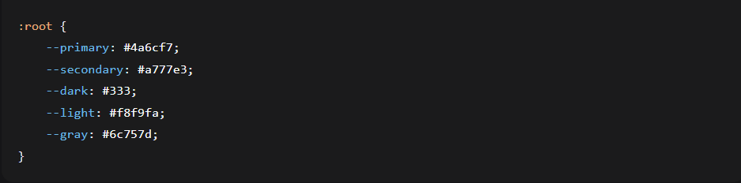

Fig. No. 2.2.1 Code Snippet For CSS Custom Properties For Theming

Variables defined in the :root selector allow for consistent theming across the entire application. Changing a value in one place (e.g., --primary) updates it everywhere it is used, ensuring design consistency and ease of maintenance.

2.2.2 CSS Flexbox for One-Dimensional Layouts:

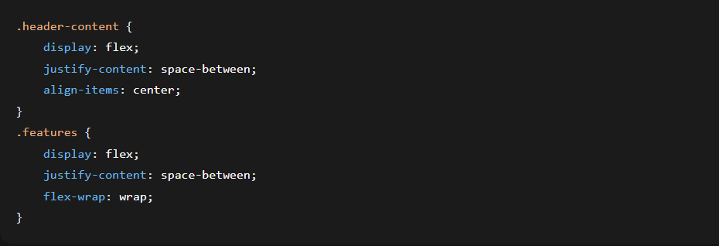

Fig. No. Code Snippet For One Dimensional Layouts

Flexbox is used for the header (to space out the logo and nav) and the features section on the home page (to arrange the three feature cards in a row). flex-wrap: wrap ensures the cards stack vertically on smaller screens.

2.2.3 CSS GRID FOR TWO DIMENSIONAL LAYOUTS

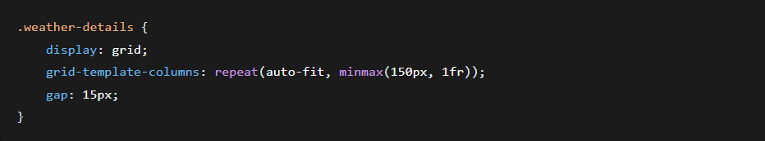

Fig. No. Code Snippet For Two Dimensional Layouts

This is a powerful technique for the weather details. grid-template-columns: repeat(auto-fit, minmax(150px, 1fr)) automatically creates as many columns as can fit in the container, with each column having a minimum width of 150px and expanding to share the available space (1fr). This creates a perfectly responsive grid without needing media queries for this specific component.

2.2.4 MEDIA QUERIES FOR RESPONSIVE DESIGN

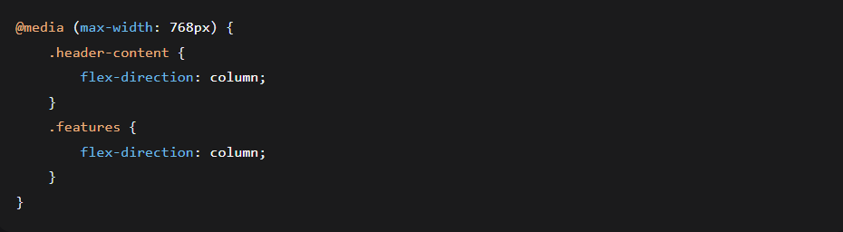

Fig. No. Code Snippet For Media Queries For Responsive Design

Media queries apply different CSS rules based on the viewport width. The rule above triggers on screens less than 768px wide, changing the header and features layout from a row to a column for better mobile usability.

2.2.5 ANIMATIONS AND TRANSITIONS

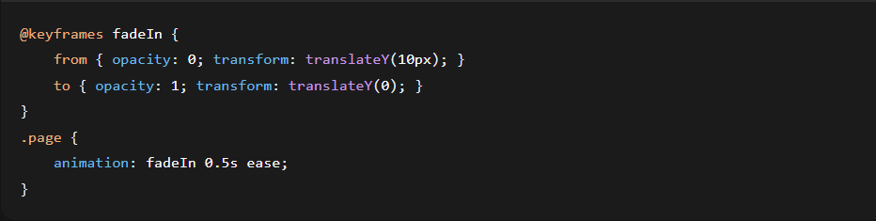

Fig. No. Code Snippet For Animations And Transitions

@keyframes defines a custom animation (fadeIn) that is applied when a new page section becomes active.

transition smoothly animates the change of properties, such as background color when hovering over a navigation link.

JAVA SCRIPT ES6+: MODERN LANGUAGE FEATURES

Vanilla JavaScript provides the application's interactivity, data handling, and dynamic behavior. The code utilizes modern ES6+ syntax and APIs.

Key Implementation Examples from Code:

2.3.1 const and let for Variable Declarations:

const apiKey = 'e7a232db2cf544e993d60744250911';

let users = JSON.parse(localStorage.getItem('weatherUsers')) || [];

const is used for variables that will not be reassigned (like the API key), making the code more predictable.

let is used for variables that will be reassigned (like the users array).

2.3.2 Arrow Functions and Template Literals:

document.querySelectorAll('.nav-link').forEach(link => {

link.addEventListener('click', function(e) {

e.preventDefault();

const targetPage = this.getAttribute('data-page');

// ... logic to switch pages }); });

Arrow Functions (=>) provide a more concise syntax for function expressions.

Template Literals (backticks `) are used for string concatenation, allowing for embedded expressions (e.g., fetch(`https://...&q=${location}`)).

2.3.3 DOM Manipulation and Event Handling:

document.getElementById('current-temp').textContent = Math.round(current.temp_c);

document.getElementById('weather-icon').innerHTML = `<i class="${icon}"></i>`;

JavaScript dynamically updates the page content by selecting DOM elements and modifying their content (textContent, innerHTML).

addEventListener is used extensively to handle user interactions like clicks and form submissions.

2.3.4 THE FETCH API FOR ASYNCHRONOUS OPERATIONS

fetch(`https://api.weatherapi.com/v1/current.json?key=${apiKey}&q=${location}&aqi=no`)

.then(response => response.json())

.then(data => displayCurrentWeather(data))

.catch(error => showToast('Error fetching weather data.', 'error'));

The Fetch API is a modern replacement for XMLHttpRequest and is used to make HTTP requests to the WeatherAPI. It returns a Promise, which is handled with .then() for success and .catch() for errors. This is a fundamental pattern for handling asynchronous operations in modern JavaScript.

2.3.5 Array Methods for Data Management:

if (users.find(user => user.email === email)) {

showToast('An account with this email already exists!', 'error');

return;

}

The .find() array method is used to search the users array for an existing user with the same email during registration, demonstrating functional programming patterns for cleaner code.

WEB APIs AND EXTERNAL SERVICES

The application leverages specific Web APIs provided by the browser and integrates with external services.

2.4.1 WEB STORAGE API

localStorage.setItem('weatherUsers', JSON.stringify(users));

let currentUser = JSON.parse(localStorage.getItem('currentUser'));

WeatherAPI.com (External REST API):

This is a third-party service that provides the weather data. The application acts as a client, sending requests to its endpoints and processing the JSON responses it receives.

Font Awesome (External CDN):

The icons used throughout the application (sun, cloud, lock, etc.) are loaded from the Font Awesome Content Delivery Network (CDN), reducing the application's file size and leveraging a professionally maintained icon library.

localStorage allows the application to store data (user accounts, active session) directly in the user's browser. This data persists even after the browser is closed, enabling the client-side authentication system. JSON.stringify() and JSON.parse() are used to convert JavaScript objects to strings for storage and back again.

CHAPTER 3

REQUIREMENT SPECIFICATION

HARDWARE REQUIREMENTS
The hardware requirements for developing and running the WeatherInfo application are minimal, as it is a client-side web application that runs entirely in a web browser.
Table 4.1.1: Hardware Requirements Specification
Component | Minimum Requirements | Recommended Requirements | Purpose
Processor | 1 GHz single-core processor | 1.5 GHz dual-core processor or faster | To handle JavaScript execution and DOM manipulations efficiently.
Memory (RAM) | 2 GB | 4 GB or more | To ensure smooth operation of the browser and application, especially when multiple tabs are open.
Storage | 100 MB of free space | 500 MB of free space | For storing the operating system, web browser, and project files. The application itself requires negligible storage.
Display | 1024x768 resolution | 1366x768 resolution or higher | To properly view the responsive layout and all UI components.
Network | Stable internet connection (3G or broadband) | Broadband connection (5 Mbps+) | Mandatory. Required to fetch weather data from the external API and load icon fonts.
Input Devices | Standard keyboard and mouse | Standard keyboard and mouse | For interacting with the application's forms and navigation elements.

Justification: The application is not computationally intensive. The primary hardware dependency is a stable internet connection for API consumption. The recommended specifications ensure a smoother development and user experience, particularly for testing responsive designs across different viewports.

SOFTWARE REQUIREMENTS

The software requirements are categorized into development and production (client) environments.

Table 4.2.1: Software Requirements Specification
Category | Software / Technology | Version / Details | Purpose
Development Environment | Code Editor | Visual Studio Code, Sublime Text, or Any modern text editor | For writing and editing HTML, CSS, and JavaScript code.
 | Web Browser | Google Chrome, Mozilla Firefox, Microsoft Edge | For testing and debugging during development. Developer tools are essential.
 | Version Control | Git with GitHub / GitLab | For source code management, version tracking, and collaboration (optional).
 | Local Server | Live Server (VS Code Extension) or Python HTTP Server | To serve the project files during development to avoid CORS issues, especially with API calls.

Production (Client) Environment | Web Browser | Google Chrome, Mozilla Firefox, Apple Safari, Microsoft Edge | Modern browsers (released 2020 or later) that support ES6+ JavaScript, CSS Grid, and Flexbox.
 | JavaScript | Must be enabled in the browser. | Mandatory. The application's core functionality relies on client-side JavaScript.
 | Operating System | Windows 10+, macOS 10.14+, Linux, Android 8+, iOS 12+ | Any modern OS that can run a compatible web browser.
External Dependencies | WeatherAPI.com | A free or paid account with an API key. | The sole source of real-time and forecasted weather data for the application.
 | Font Awesome | Version 6.4.0 (via CDN) | Provides the icon set used throughout the application's UI.
 | Internet Connection | Active and stable connection. | Mandatory. Required to load the external API and CDN resources.

Justification for Key Software Choices:
- Modern Browsers: The application uses modern web standards like ES6+ JavaScript (Arrow Functions, const/let, Fetch API), CSS Grid, and Flexbox. These are consistently and fully supported in browsers released from approximately 2020 onwards.
- Local Server: Using a simple local HTTP server during development is crucial. Opening the html file directly (file:// protocol) can cause the Fetch API requests to the weather service to fail due to CORS (Cross-Origin Resource Sharing) policies.

- _
- API Key: The WeatherAPI.com service is free for development with a limited number of requests per month, which is sufficient for a project of this scale.

CHAPTER 4
DESIGN

4.1 SINGLE PAGE APPLICATION ARCHITECTURE

The application follows a SPA architecture where all necessary code is loaded once, and page content is dynamically updated without full page reloads.
Key Design Decisions:
- Client-Side Routing: Navigation between sections is handled entirely in JavaScript using data-page attributes
- Modular Section Management: Each main feature (Home, Weather, Profile, etc.) is implemented as a separate section that can be shown/hidden
- State Management: Application state (current user, weather data) is managed in memory and persisted via localStorage

4.2 Component-Based UI Structure
The interface is built using reusable component patterns:
4.2.1 Card Components:
html
<div class="feature">
<i class="fas fa-sun"></i>
<h3>Current Conditions</h3>
<p>Get real-time weather data including temperature, humidity, wind speed, and more.</p>
</div>
- Consistent styling with shadows and borders
- Reusable across different sections (features, weather details, forecast)

4.2.2 Form Components:
html
<div class="form-group">
<label for="login-email">Email Address</label>
<input type="email" id="login-email" placeholder="Enter your email" required>
<i class="fas fa-envelope input-icon"></i>
</div>
- Standardized input fields with icons
- Consistent validation and error handling
- Reusable across login and registration forms

4.3 Responsive Design Strategy
The application implements a mobile-first responsive design:
Breakpoint Strategy:
- Default: Mobile-optimized layout (stacked elements, larger touch targets)
- ≥768px: Tablet/desktop adaptations (horizontal layouts, grid systems)
- Component-specific: Some elements (like weather details grid) use intrinsic responsive patterns
Flexible Layout Patterns:
- Flexbox for one-dimensional layouts (headers, feature cards)
- CSS Grid for complex two-dimensional layouts (weather details, forecast)
- Relative units (%) and max-width for fluid containers

CHAPTER 5

IMPLEMENTATION

5.1 SINGLE PAGE APPLICATION NAVIGATION

The core SPA functionality is implemented with a lightweight routing system:
Javascript:

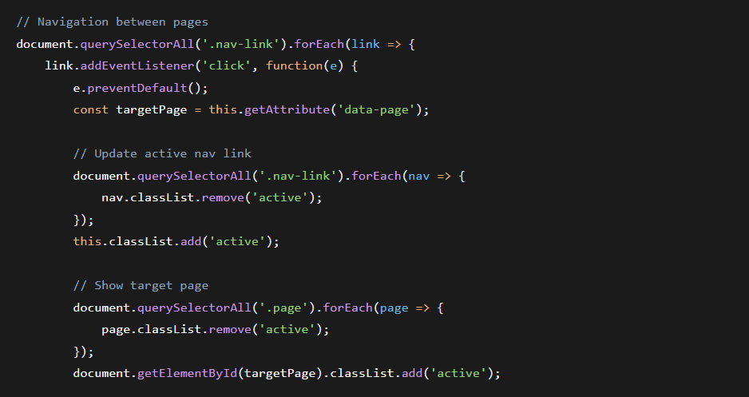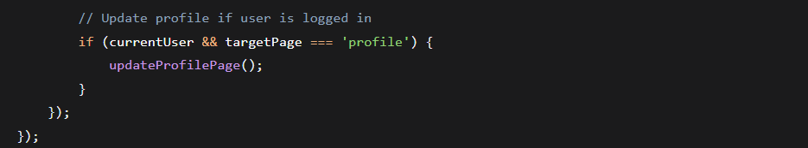

Fig. No. 5.1 Single Page Application Navigation
5.2 Weather API Integration Module

The weather module handles external data retrieval and presentation:
Javascript:
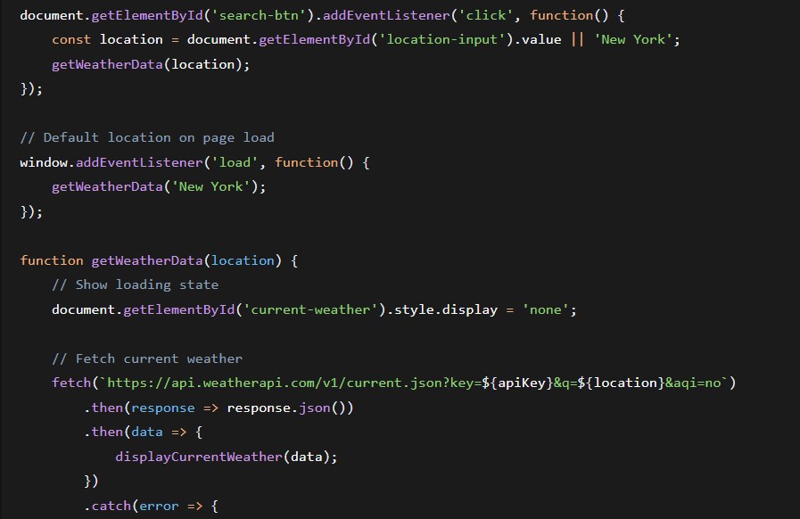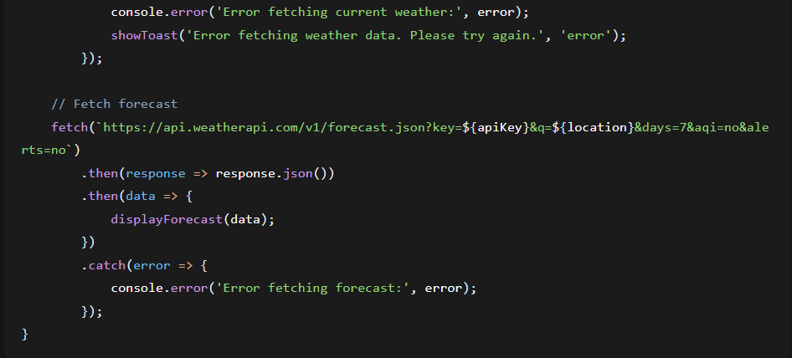

Fig. No. 5.2 Weather Api Integration Model

5.2.1 Data Processing and Display:

Javascript:

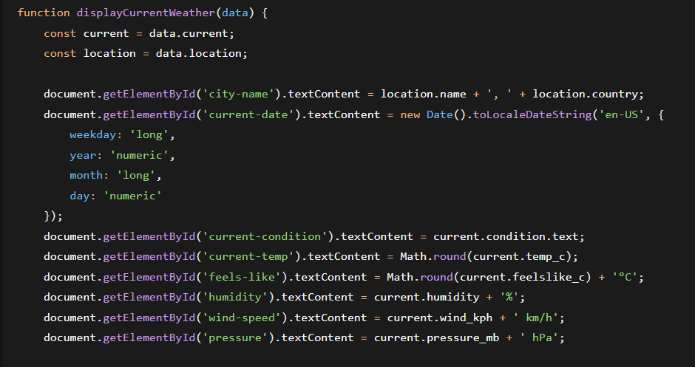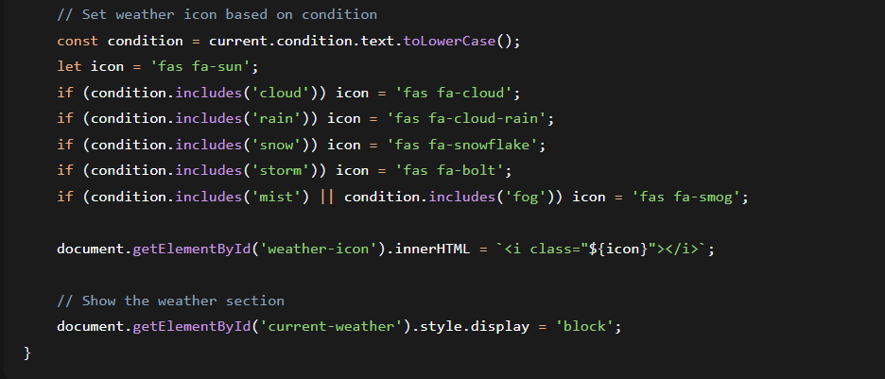
Fig. No. 5.2.1 Data Processing and Display

5.3 User Authentication System

The client-side authentication system manages user accounts and sessions:

5.3.1 User Registration:

Javascript:

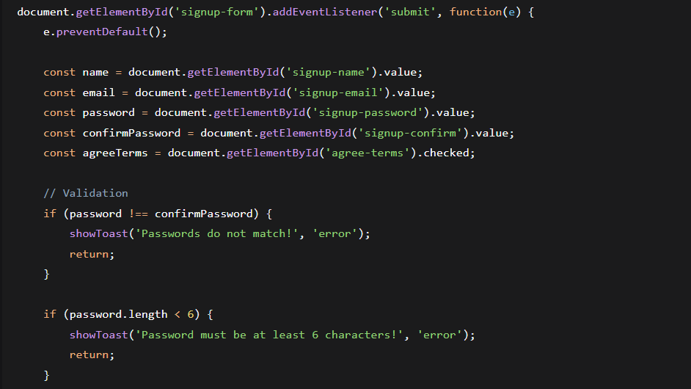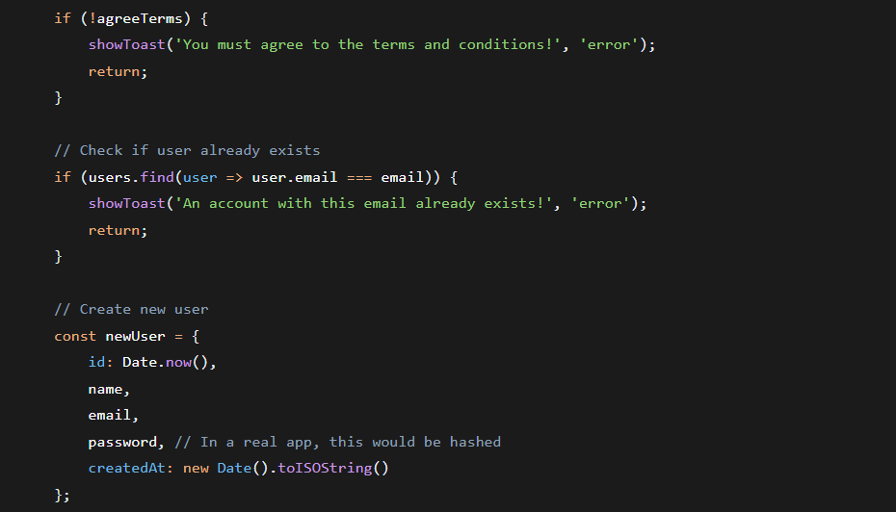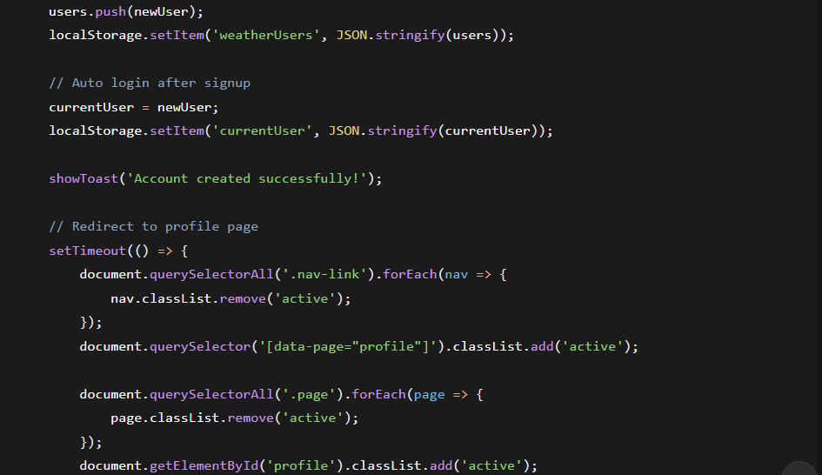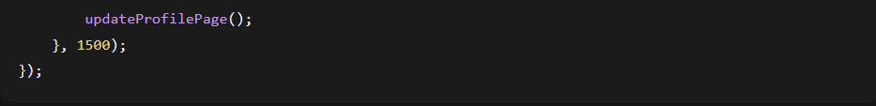
Fig. No. User Registration
5.3.2 SESSION MANAGEMENT

Javascript:

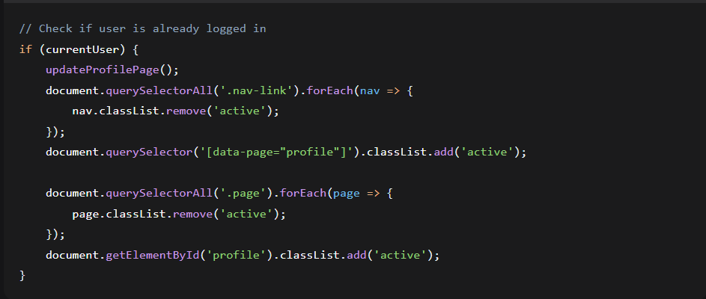
Fig. No. 5.3.2 Session Management

5.4 User Interface Components and Interactions

5.4.1 Toast Notification System:
Javascript:

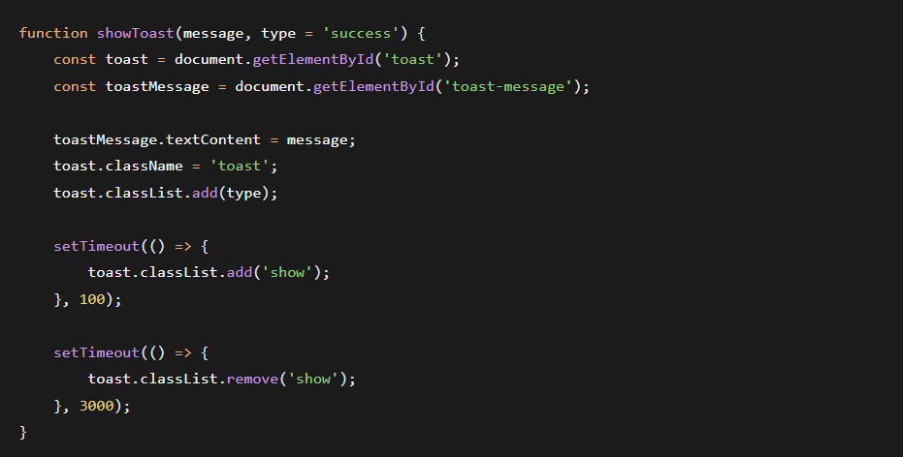
Fig. No. 5.4.1 Toast Notification System

5.4.2 Password Visibility Toggle:
Javascript

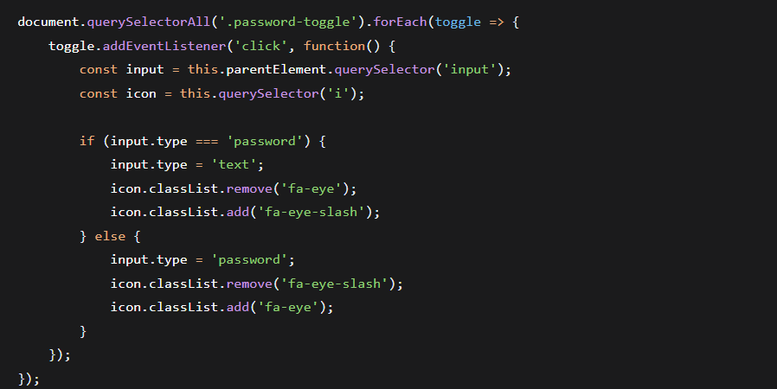

Fig. No. 5.4.2 Password Visibility Toggle
CHAPTER 6

RESULTS

6.1 HOME PAGE

The Home page serves as the landing page, providing users with an introduction to the application's capabilities. As shown in the figure, the interface features a clean, modern design with a prominent hero section containing the title "Stay Ahead of the Weather" and a persuasive subtitle. The primary call-to-action button "Check Weather Now" is prominently displayed, guiding users toward the main functionality. Below the hero section, three feature cards are arranged using CSS Flexbox, each with a representative icon from Font Awesome, a title, and a brief description. These cards highlight the key features: "Current Conditions," "7-Day Forecast," and "Global Coverage." The responsive design is evident, with the layout adapting seamlessly to different screen sizes. The navigation bar at the top consistently provides access to all sections of the Single-Page Application.

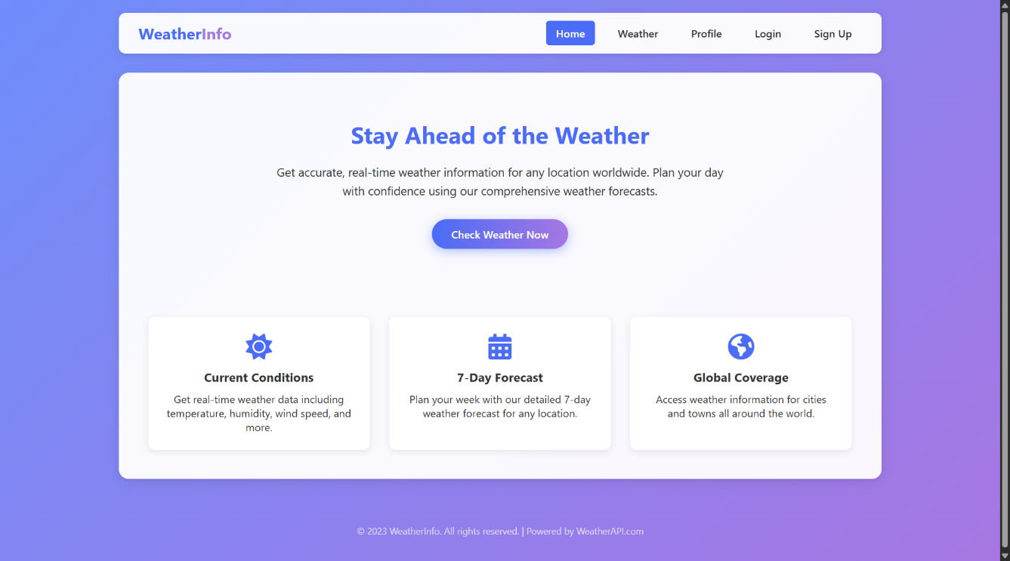
Fig 6.1:Home Page

RESULTS

6.2 WEATHER DASHBOARD WITH DATA

The Weather page is the core of the application, successfully demonstrating the integration with the WeatherAPI.com service. The figure shows the search bar at the top, where users can input any city name. The main weather card displays the current conditions for the searched city (e.g., "London, UK"). Key data points are clearly presented: the current temperature (e.g., "15°C"), the weather condition ("Partly Cloudy"), and a corresponding icon. Below this, a grid layout (implemented with CSS Grid) efficiently organizes additional meteorological details such as "Feels Like," "Humidity," "Wind Speed," and "Pressure." The 7-day forecast section is populated dynamically, with each day showing the day name, a weather icon, and the high/low temperatures. This layout confirms the successful implementation of asynchronous JavaScript, DOM manipulation, and data presentation logic.

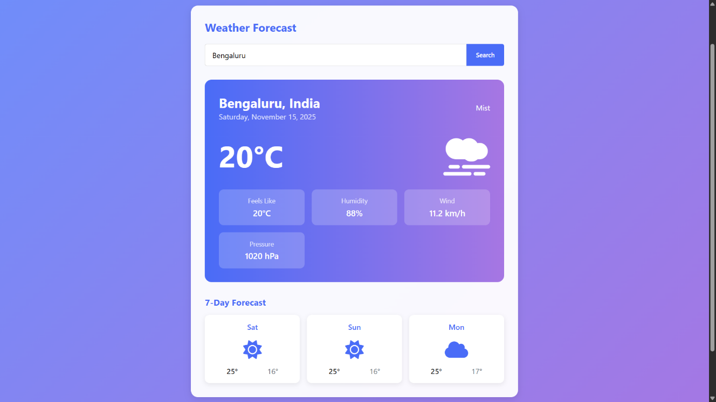
Fig 6.2:Weather DashBoard

6.3 USER AUTHENTICATION INTERFACES

The user authentication system is fully functional on the client side. The left side of the figure shows the Login form, which includes input fields for email and password, a "Remember me" checkbox, and a "Forgot password?" link. The right side shows the Signup form, which collects the user's full name, email, password, and password confirmation, and includes a mandatory terms of service agreement checkbox. Both forms feature the password toggle functionality (eye icon), allowing users to show or hide their entered password. The forms include client-side validation, which provides immediate feedback. For example, if the passwords do not match during signup, a red error toast notification is displayed. The social login buttons (Google, Facebook, Twitter) are present as placeholders, demonstrating areas for future integration.

6.3.1 LOGIN PAGE

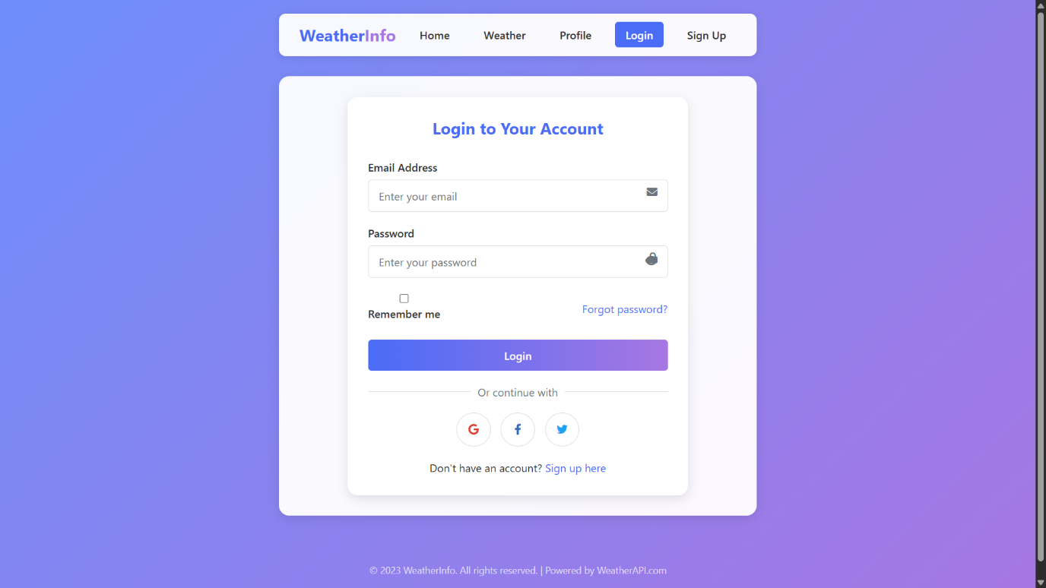
Fig 6.3.1: Login Page

6.3.2 SIGNUP PAGE

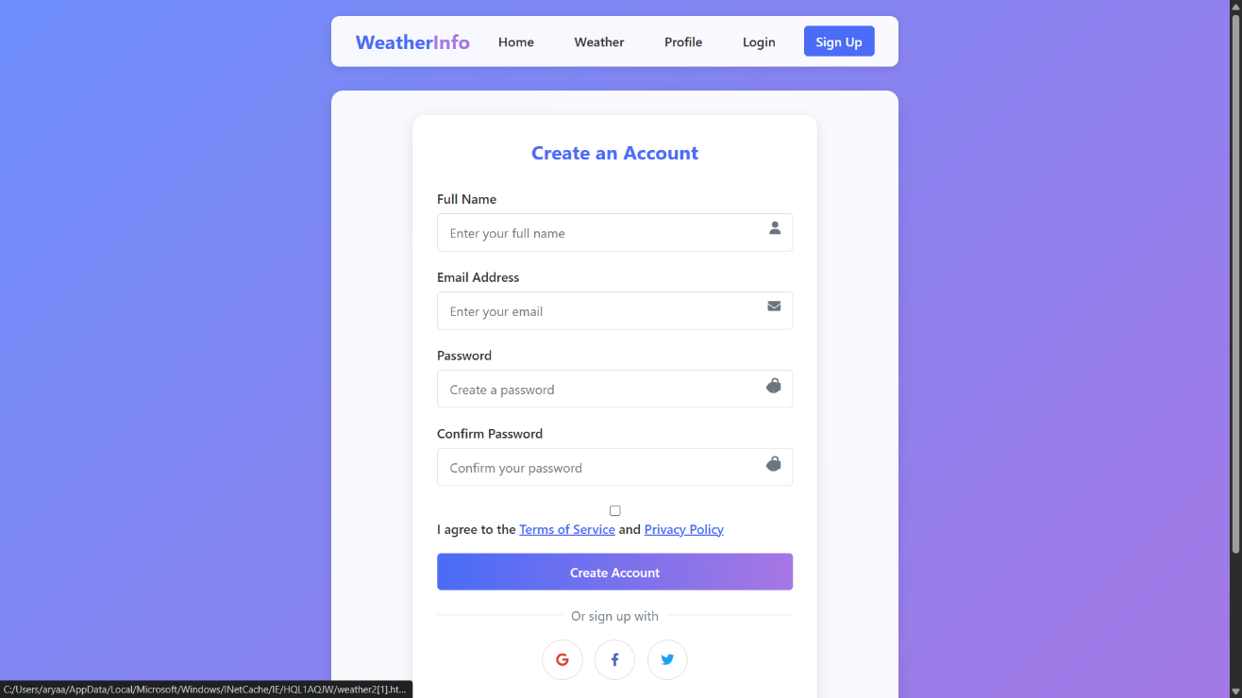
Fig 6.3.2: SignUp Page

6.4 PROFILE MANAGEMENT PAGE

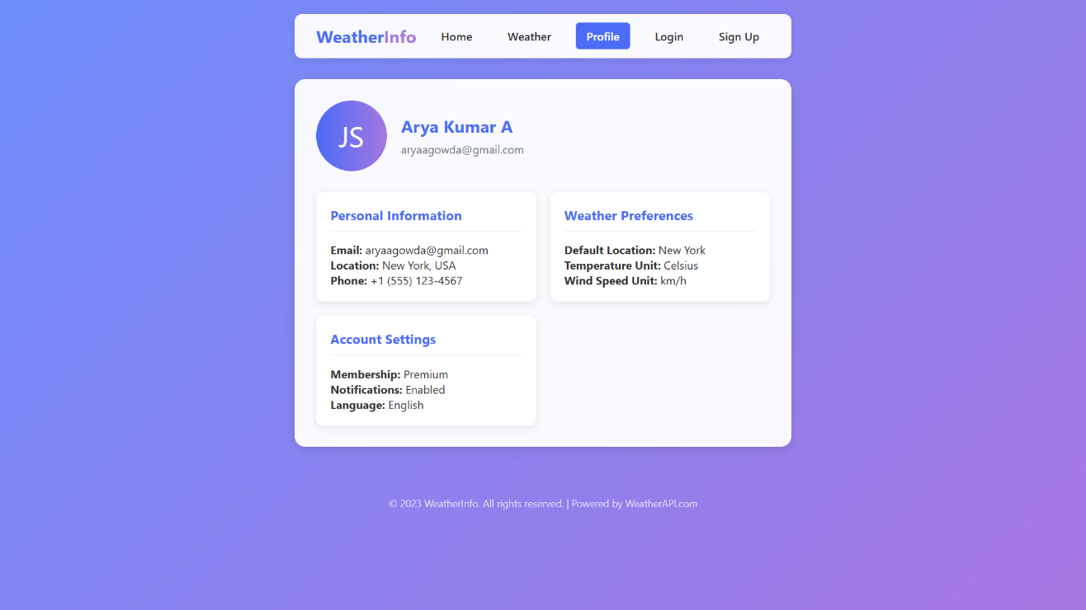
Fig 6.4: Profile Management Page

The Profile page is dynamically updated upon user login, showcasing the integration with the browser's Local Storage API. The figure displays the profile header, which includes an avatar generated from the user's initials (e.g., "JS" for John Smith) and the user's name and email address, all pulled from the currentUser object in localStorage. The profile details are organized into three distinct cards: "Personal Information," "Weather Preferences," and "Account Settings." This page confirms that the authentication workflow is complete, from registration and login to session persistence and personalized data display. The information shown is static for the demo but is successfully bound to the logged-in user's data.

CHAPTER 7

CONCLUSION

WeatherInfo successfully demonstrates the design and implementation of a dynamic, responsive single-page web application using core web technologies. All primary objectives were achieved: seamless SPA navigation, modern responsive UI, real-time weather data integration, and functional client-side authentication. The project serves as a solid foundation in modern web development practices, showcasing effective use of HTML5, CSS3, and JavaScript to build a practical application without external frameworks.

REFERENCES

- MDN Web Docs. (2023). HTML: HyperText Markup Language. Mozilla Developer Network. Retrieved from https://developer.mozilla.org/en-US/docs/Web/HTML
- MDN Web Docs. (2023). CSS: Cascading Style Sheets. Mozilla Developer Network. Retrieved from https://developer.mozilla.org/en-US/docs/Web/CSS
- MDN Web Docs. (2023). JavaScript. Mozilla Developer Network. Retrieved from https://developer.mozilla.org/en-US/docs/Web/JavaScript
- MDN Web Docs. (2023). Fetch API. Mozilla Developer Network. Retrieved from https://developer.mozilla.org/en-US/docs/Web/API/Fetch_API
- MDN Web Docs. (2023). Window.localStorage. Mozilla Developer Network. Retrieved from https://developer.mozilla.org/en-US/docs/Web/API/Window/localStorage
- WeatherAPI.com. (2023). Weather API Documentation. Retrieved from https://www.weatherapi.com/docs/
- Font Awesome. (2023). Icon Library and Toolkit. Retrieved from https://fontawesome.com
- Flanagan, D. (2020). JavaScript: The Definitive Guide, 7th Edition. O'Reilly Media.
- Meyer, E. A. (2018). CSS: The Definitive Guide, 4th Edition. O'Reilly Media.
- Keith, J. & Andrews, C. (2015). Resilient Web Design. Retrieved from https://resilientwebdesign.com/

